Policy Manual for Gallery Underground

Member Artist’s Responsibilities
Monthly Submissions
Each month 2D Artists may submit up to 4 works totaling no more than 4ft across by 4ft vertical (including sufficient space between those works). Original works only may be submitted. Giclees, prints or other reproduced work is prohibited, except by photographers. Each work must be professionally framed with clean glass, clean mat boards, and appropriate wiring. All canvases must be either framed or have finished gallery-wrapped painted edges. 2D Artists may also bring in 3 shrink wraps and several boxes of notecards. No giclees or other reproductions (except for photographs) are permitted in the shrink wrap bin – original works only. 3D Artists may submit 6 – 8 works, as well as 3 smaller works with lower prices (see Pricing, below) or 3 shrink wraps. The Gallery provides pedestals/display space. However, in some cases 3D Artists may provide special stands for their work which they can offer for sale if they choose.
Volunteering at Receptions
Receptions are held the first Friday of every month between 5pm and 7pm. Artists are required to volunteer at at least 3 of the 6 receptions held during 6-month contract period, and one of these must be a “cleanup” slot.
Procedures for Delivery of Artwork
Artists will receive an email the week before receiving with instructions. Delivery/pick-up of artwork is scheduled for the week leading up to the first Monday of the month (“Installation Monday” )– installation sometimes occurs on Saturday or Sunday depending on the installation crew’s schedules.) Receptions for the new shows are always held on the first Friday of the month, so the show is always hung the Saturday, Sunday or Monday preceding this. We encourage artists to bring their work as close to Friday as possible or ON the Friday preceding Installation Monday. If work is brought in before Friday, it will be stored in the painting rack in the back room. Work brought in on Friday will be put against the walls. Artists will type their own labels and attach them to the back of their work (see label template below). Artists will also bring an inventory sheet which must list the Artist’s Name, Title, Media, and Price for each work. Shrink wraps must be listed separately on the inventory and designated as shrink wraps. Notecards are not listed on inventory. Artists do their own labels for shrinkwraps and notecards.
Artists are responsible for delivering their 2D/3D works to the Gallery or arranging for another Artist to deliver them. Artists shall not ask Directors to transport art for them. Any work not picked up from previous show will be stored in the back room of the gallery.
Work may also be delivered at 10:00am the morning of Installation Monday, (or Saturday or Sunday) which is always the Monday preceding the first Friday of the month. Because the Exhibition Committee begins hanging promptly at 10:00am, any work brought to the Gallery after 10:00am will not be accepted. No exceptions.
The parking garages closest to the Gallery are free daily after 4:00pm. All other times they are $6.00/hr up to 2 hours, and then $21.00 flat rate for parking over 2 hours.
Pricing
No framed work may be priced below $100. Exceptions to this rule may be made for special shows. Shrinkwraps may be priced below $100. 3D Artists may also submit 3 smaller works priced under $100. The Gallery adds the applicable sales tax to the price of works when they sell. Artwork prices should not include tax, and should be rounded up in increments of $25, with one exception, i.e., work is permitted to be priced in increments of $195, $295, etc. Artists provide the Gallery with information on whether prices are negotiable. If a discount is requested by a buyer, the Gallery will contact the Artist before applying a discount.
Purchase of Artworks
When artwork is purchased, the customer takes it with him/her directly. When an Artist’s work sells, the Gallery will contact the Artist with information on work sold, the name and address of the buyer, and a request that the Artist bring in another piece to replace the sold piece as soon as possible. The gallery AND Arlington Artists Alliance websites also have online stores. 2 pieces from every monthly Gallery show will be put into the online Gallery Underground website store, and members may also submit 1 or 2 works to the Arlington Artists Alliance website store – that work is changed out every few months. When a piece sells online, if it is not from the current show hanging at the gallery, Artist will bring the work in for gallery staff to ship or hand deliver.
Grievance Procedures
If an artist has a concern or complaint, he or she should address it with one of the Gallery Directors in a professional manner and never in the presence of gallery clients or others. If the artist continues to be dissatisfied, he or she is free to bring the matter to the attention of the Gallery’s Executive Director. Membership in the Gallery and Alliance is a privilege. Unprofessional behavior toward any Gallery Director, member, or official may result in temporary or permanent suspension by decision of the full Board with no refund of gallery rent.
Hanging Shows
The exhibits are hung by the Employees and the Exhibition Committee – a committee of member volunteers with extensive experience hanging art exhibits. In general, exhibits are hung at the Gallery on the first Monday after work is delivered. The Exhibition Committee strives to organize the submitted artworks in the most attractive manner possible. Work tends to be organized by color palette and size, rather than by theme. No preference is given to particular artists during the hanging process.
Gallery Hanging Procedures
The Gallery Directors and the gallery hanging committee have responsibility for hanging and arranging all monthly and special shows in the gallery. Their decisions regarding the location of each artists’ works are based on a wide variety of factors including size, color, and subject matter of each piece and, most importantly, the overall aesthetic effect and the attractiveness of the show and the gallery. Their decision regarding the hanging and location of each work is final and not subject to further review. Once a show is hung, it is not appropriate for any artist to seek to have their own artwork moved to a different or more prominent location in the gallery.
Only professional-looking work framed in an appropriate manner will be accepted to be hung in the Gallery. Artwork with nicked or marred frames, soiled or poorly cut mats, and/or dirty or scratched glass or visible/obvious repairs of frames will not be hung. Frames and canvas must have proper framer’s hanging wire attached to the back. The use of spring clips or tape to hold canvases into frames is not permitted. Canvases should be securely screwed into frame. Similarly, 3 Dimensional work must be stable and (if applicable) securely attached to its base. Wobbly or precarious sculptures will not be displayed. See Framing Standards provided.
Artworks that seem to be of poor quality compared to that Artist’s usual work may not be hung. The Employees along with the Exhibition Committee have final say as to whether a particular artwork meets gallery standards or not. As such, an Artist who submits inferior work may be asked to submit a replacement piece.
Attached are: a photograph showing the appropriate number and size of works that may be submitted, Framing Standards, and a copy of the Gallery’s Inventory Sheet.

Scroll down for illustration of amount of works artists may display each month

Appropriate Amount of 2D Work to Submit Monthly

Each month, 2D artists are allowed to submit up to 4 paintings that fit into a 4’ x 4’ space as long as there is enough room for space between each painting.
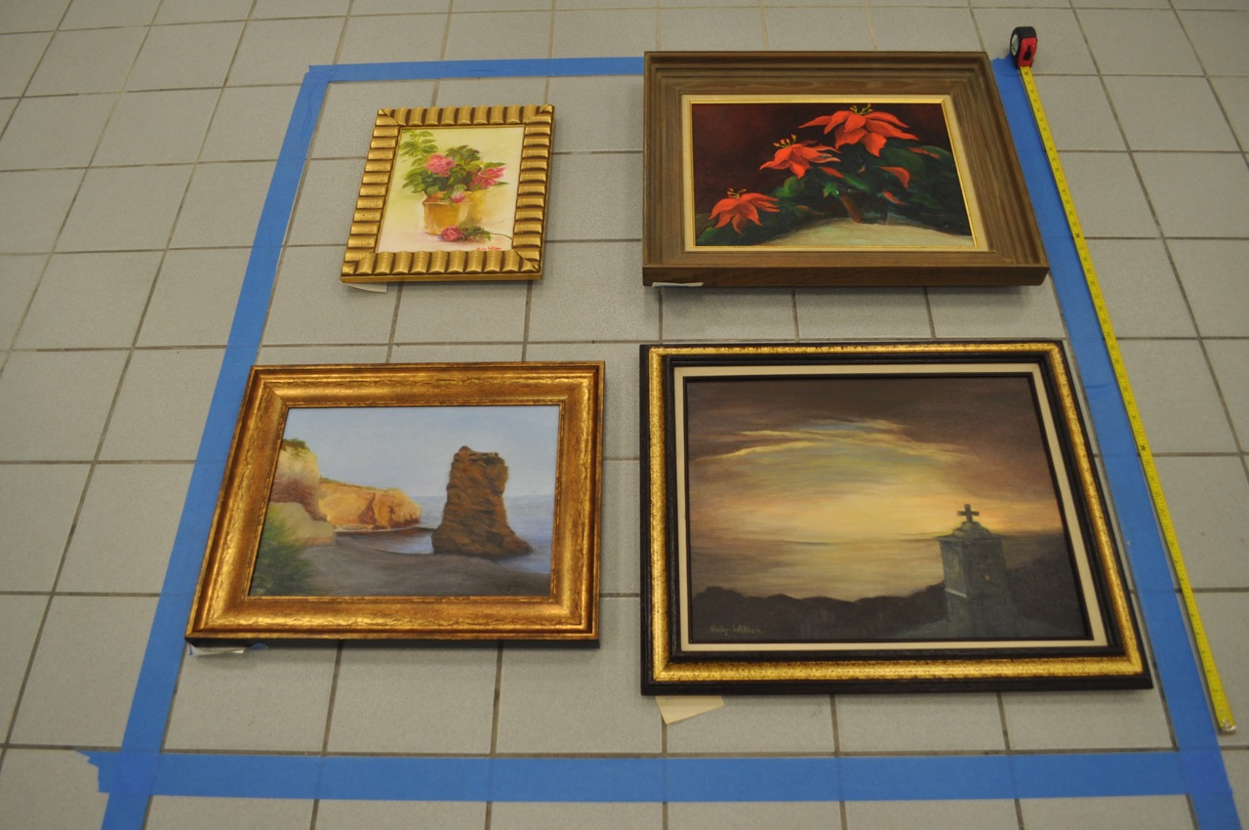

Scroll down for label template, framing guidelines and inventory sheet
LABEL TEMPLATE FOR ALL GALLERY WORKS TO BE DISPLAYED

Artist Name
Title
Medium $

Artist Name
Title
Medium $

Artist Name
Title
Medium $

Artist Name
Title
Medium $

Artist Name
Title
Medium $

Artist Name
Title
Medium $

Pg. 1 of 4
Framing and Presentation Guidelines
For Gallery Underground

HANGING APPARATUS:

• NO clip frames or saw tooth hangers, please. They tend to fall off the wall.

What are clip frames or saw tooth hangers?

Saw Tooth Hanger:

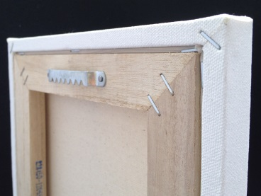 NO

Clip Frames:

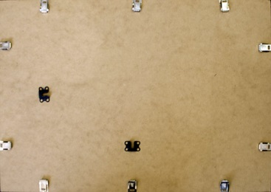 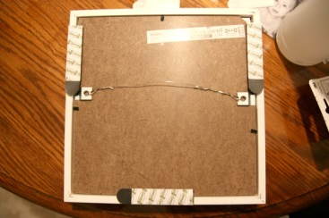 NO

These won’t hold either:

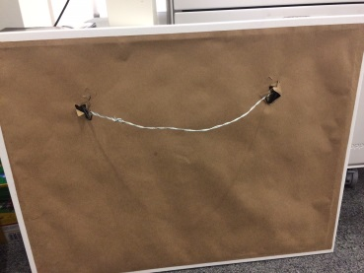 NO 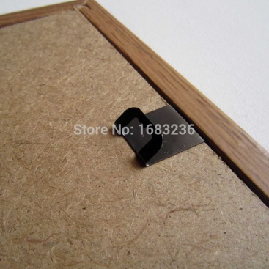NO More…

Page 2 of 4
• Works must be securely and suitably framed with screw eyes/D-Rings and wires firmly attached to the frame itself, not to the backing because they can come loose and damage the artwork

ACCEPTABLE HANGING APPARATUS:

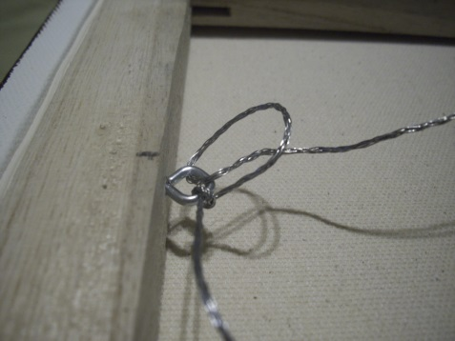
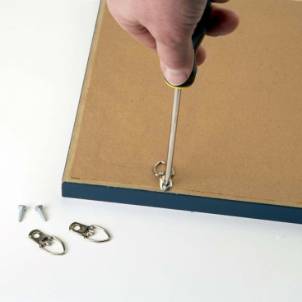

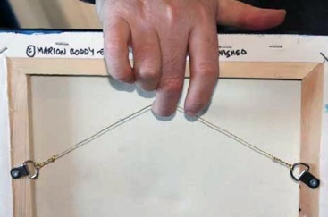

YES YES YES

- Wires must be attached 1/3 from the top of the artwork for wall installation. Wires should not reach the top of the artworks:

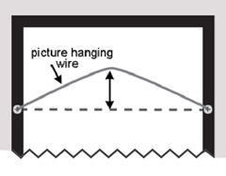

YES

HOW WORK IS HELD IN FRAME

- Do not use spring clips to hold canvases in place. They don’t hold well enough.

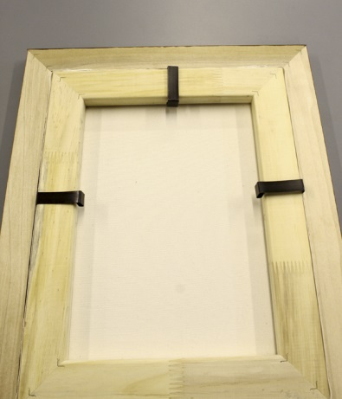
What are spring clips?

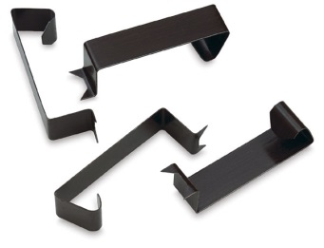

NO More…

Page 3 of 4
ACCEPTABLE METHOD OF ATTACHING PAINTING TO FRAME:

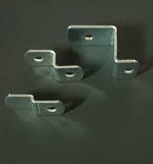
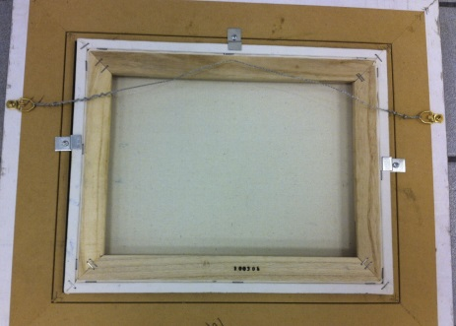

YES – Use these to screw painting in

- Do not tape work into frame

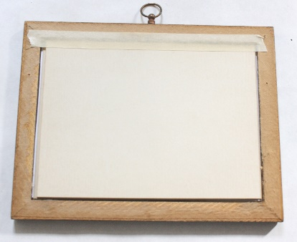No
- Paintings on panel should be held in with points attached via a point driver:

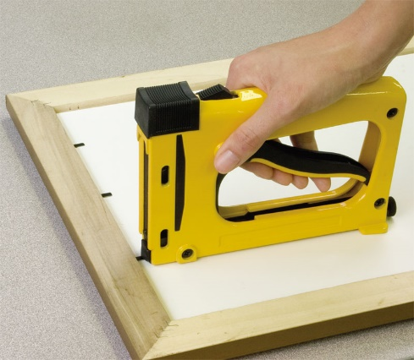YES – POINT DRIVER

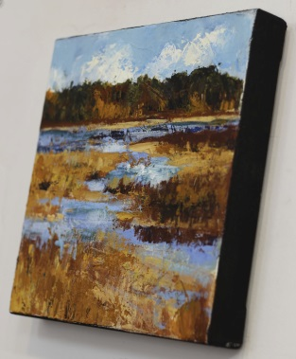
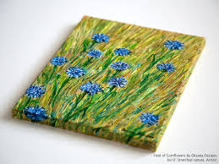
• Gallery-wrapped canvases may be submitted unframed. Note: edges must be finished; no staples, tacks, or tape visible.

YES – SIDES PAINTED

MORE….

Page 4 of 4

- Please use frames in good condition. No chipped paint, scratches, etc. We advise not getting frames at yard sales and store bargain bins. They do not do your work justice!

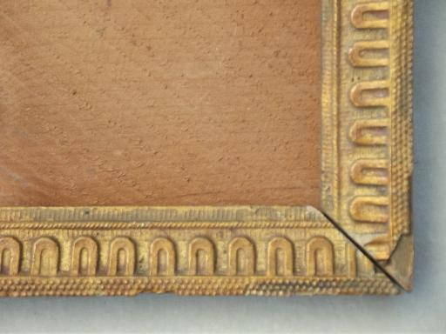

NO – DAMAGED FRAME

• Photographs are not acceptable on stretched canvas. Matted under glass or mounted on metal are acceptable. If you have other methods of presenting photographs, please check with gallery staff.

• Works on paper should be matted and any work with a paper mat must have a protective covering of glass or Plexiglas. MAKE SURE GLASS IS NOT CHIPPED, SCRATCHED OR BROKEN.

- IF YOU ARE NOT A PROFESSIONAL MAT CUTTER, PLEASE HAVE A FRAMER CUT YOUR MAT FOR YOU. Mats that are poorly cut or dirty/smudged will not be accepted.

- Still wet work or incomplete work will not be exhibited.

HOW LABELS SHOULD BE PRINTED:

- All Alliance labels should be printed on using template provided (see above), on CARD STOCK (not regular copy paper)

- All Alliance labels should be printed on a computer, not hand-written

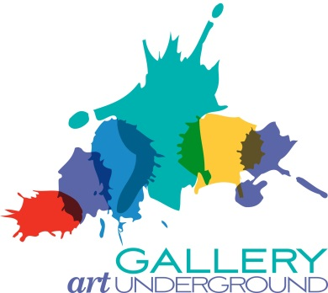
Gallery Underground
ARTIST’S INVENTORY FORM

Artist Name________________________________________
Month/year _________________________________________

Title | Medium | Size | Price | For office use only  Buyer Name/Address

